Type the Title here using Upper and Lower Case in 12 Points Arial, Bold, Centered

Presenting author's first name and family name^{1, 2}, 2nd author's first name and family name², etc.
¹author's affiliation, city, country, email address
²author's affiliation, city, country

Enter the abstract text (use font type Times New Roman 10 points with single spaced lines. Please use this template, erase the sample texts and fill in your text. Page margins should be 3 cm for top, left, right and bottom margins. Abstract information must not appear on or outside the margins. All information must fit in one single A4 page. Abstracts must be DOC (Microsoft Word) converted to PDF. File size is limited to 2 MB. Abstract text is justified (therefore aligned along both the left and right margin of the column); paragraphs are not indented, only separated by one blank line. Paragraph headers, if needed, should be written in bold (align left). Abstracts should be written in English. Tables or images should be used when necessary to substantiate results and should be pasted into the abstract template form. Ensure that they are within the printable area of the page.
Table and Images Captions: Image captions should appear aligned under the corresponding figure and set in 10 points. Table captions should appear below the corresponding table and be set in 10 points. These items should appear as close as possible to where they are cited.

table | table | table | table
table | table | table | table
table | table | table | table
table | table | table | table
Table 1: Caption

Images can be also in color. We suggest you print your manuscript before submission.

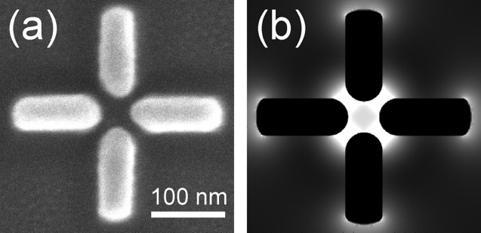
Figure 1: Caption

All abstracts must be uploaded through the provided form and the preference for oral or poster presentation must be specified in the appropriate form field.
References should appear at the end of the abstract in the order in which they are referenced in the body of the paper (style: Times New Roman points 8 aligned left). Within the main text, references should be designated by a number in brackets [1], and they should be followed by a comma or period [2]. Two references cited at once should be included together [3,4], separated by a comma, while three or more consecutive references should be indicated by the bounding numbers and a dash [1–4].

References
[1] C. van Trigt, JOSA A 14, 741-755 (1997).
[2] David F. Edwards, in Handbook of optical constants of solids, E.D. Palik, ed. (Academic, Orlando, Fla. 1985).
[3] F. Ladouceur and J. D. Love, (Chapman & Hall, 1995), Chap. 8.
[4] Author(s), in Title of Proceeding, (Institute of Electrical and Electronics Engineers, New York, 1900), pp. 00-00.

